JO Legacy Society
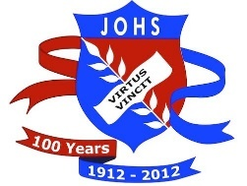
Membership Form

Name: _____________________________________________________________________
Address:____________________________________________________________________
____________________________________________________________________
Phone #: Home:_______________________ Mobile:__________________________
Email:_________________________________________________________________
Calendar Years at JO: _____ to _____
Volunteer activities that interest you:
- Member of the Committee – attend meetings
- Administrative duties – email, correspondence, etc.
- Sort and catalogue the archival materials such as photos and documents into decades and/or categories
- File items in allocated storage areas
- Digitize items for uploading to the JO Legacy Website
- Update the website
- Research and write descriptions for photos and items
- Find and record appropriate display items for school and community events, class reunions and log them in and out.
- Create displays and/or attend school or community events as a representative of JOLS
- Fundraise
- Prepare grant applications
- Other: _________________________________________________________________
- Not interested in volunteering

Add a comment and/or availability:
__________________________________________________________________________________________________________________________________________________________________________________________________________________________________________

